Designing Safe Rated Capacity Limitation: With qSCALE RCL trueSafety, WIKA Mobile Control offers functional safety combined with high availability – and the first certified software library for rated capacity limitation (RCL) of telescopic cranes.

Ettlingen, Germany / When mobile cranes lift and move heavy loads, the protection of people, material and machinery is the top priority. For this reason, functional safety combined with high availability plays an increasingly important role in the field of mobile cranes. Certified control solutions help to reduce safety risks – this applies not only to the hardware components, but also to the software, which is an essential part for the functional safety of modern applications nowadays. With qSCALE RCL trueSafety, WIKA Mobile Control presents the first software library certified acc. to DIN EN ISO 13849 for the rated capacity limitation (RCL) of telescopic cranes – and offers high flexibility in modular cSCALE control systems at the same time.

Safe rated capacity limitation – WIKA Mobile Control calls this: qSCALE RCL trueSafety. This solution for rated capacity limitation (=RCL, also known as load moment indication or LMI), is a software library for mobile cranes that is certified according to DIN EN ISO 13849. The qSCALE RCL C library has been implemented with regard to functional safety and complies with the current EU standards. All requirements of safety-related embedded software SRESW are taken into account and meet the requirements of the Machinery Directive 2006/42/EC. The development process and the implementation of the programming comply with the requirements of SIL 2 acc. to DIN EN 61508-3 and EN 62021 as well as PL d acc. to DIN EN ISO 13849. Besides the implementation of the software library, the entire development documentation is certified.

Flexible rated capacity limitation (RCL) in the cSCALE control system

At the center of the safety system is the modular cSCALE control with integrated qSCALE RCL. It can be combined with any manufacturer-independent hardware components such as sensors for measuring angles, lengths, pressure and force as well as actuators, controls, consoles or devices such as cameras. The design of a complete qSCALE system for rated capacity limitation is individually tailored to the specifications of the mobile machine. As a system integrator, WIKA Mobile Control works alongside the customer through all project phases: from analysis and concept evaluation, system design and project planning to prototype testing and field introduction.
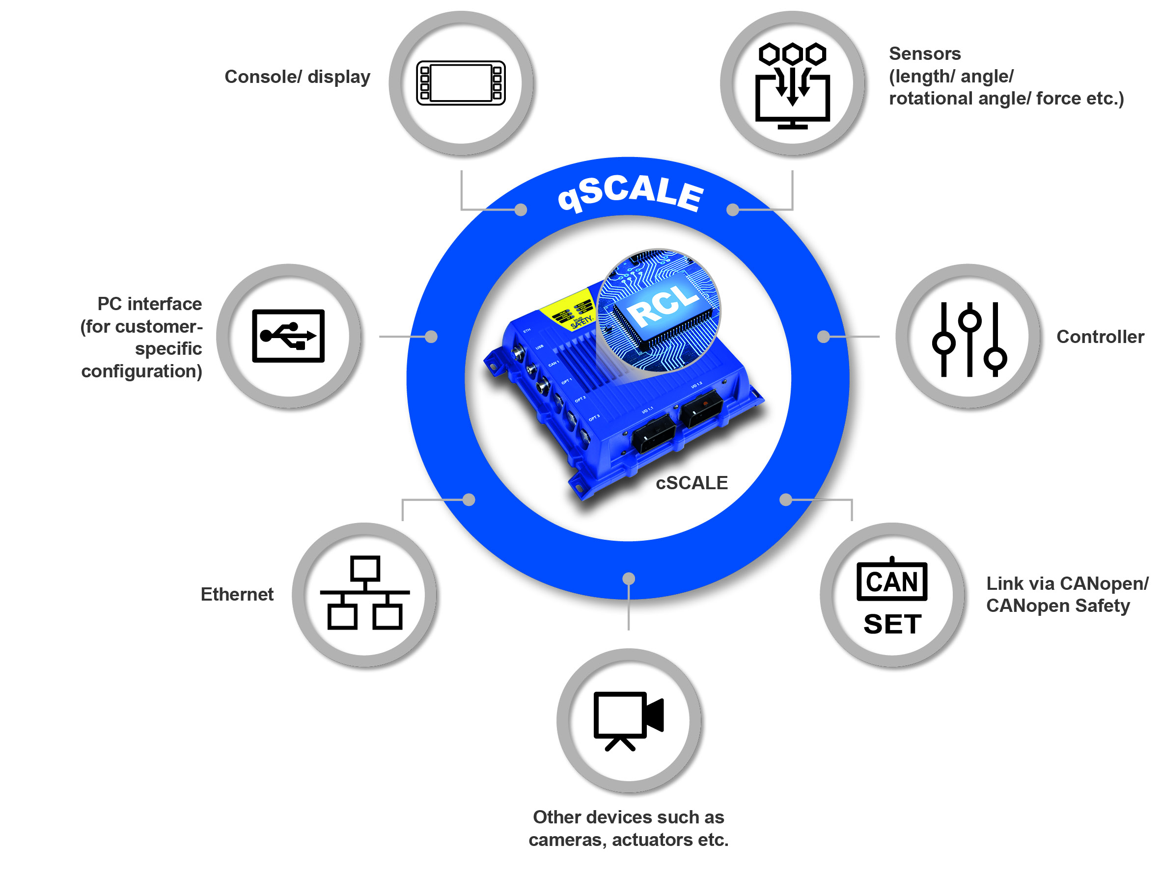
Figure 1: The qSCALE system for rated capacity limitation

Easy system configuration via the qSCALE Sx configurator

The qSCALE Sx Configurator is a Windows-based and menu-driven tool for the certified software module library qSCALE RCL trueSafety to set parameters for customer-specific configuration of mobile cranes. In addition to general machine data, such as manufacturer and machine type, the qSCALE Sx Configurator can be used to set parameters of the crane model in a customer-specific manner across the entire machine kinematics. The model consists of freely configurable elements such as telescopes, tips and other attachments. This flexibility allows the equipment of all crane models in the telescopic crane market. This data is supplemented by the customer-specific load tables. Customer-specific load tables (including multidimensional tables) can be inserted and the behavior inside and outside the load tables is configurable. For easy validation, users are provided with three-dimensional visualizations of the tables to have an overview at all times. Integrated reporting functions support the user in his functionally safe project documentation.

By using the qSCALE Sx Configurator, operating modes and the referencing of load charts to operating modes can be defined. The load charts are adjustable in response to variables and conditions, such as rotary angle, digital inputs, telescoping sequences, work ranges or counterweights. Actions and limitations such as total shutdowns, single movement shutdowns, as well as error outputs and warnings are selectable.

Finally, the qSCALE Sx Configurator can be used to define the calibration process according to the customer’s requirements and to offer the service department a menu-driven calibration procedure. The entire calibration process is recorded and documented in order to automate the release process and to analyze and optimize the entire calibration process offline without machine connection. An adaptable traffic light color system enables the recipient to easily visualize the compliance with the tolerance ranges of load and radius.

Reliable safety functions

At the center of the safety system is the modular cSCALE control with integrated qSCALE RCL. Safety mechanisms for error detection play an important role within the qSCALE system. All safety-relevant program and parameter data of the RCL C library are secured by checksums. As a result, data consistency is guaranteed. The entire calculation processes run redundantly, are controlled by cross-comparisons and are cyclically monitored by safety mechanisms, which are integrated in the cSCALE. The monitoring of compatibility of the safety-relevant program versions guarantees the correct interaction of the software modules.

CoDeSys software module library

The CoDeSys module library is the interface between the cSCALE control program and the RCL C library. The library also contains qualified modules for the functional implementation outside of the RCL C library, including modules for analog and digital I/O, signal processing, event and file handling, parameter and data handling, data logger, CANopen and CANopen safety communication. With the help of the modular system, individual applications can be programmed quickly and easily to develop certifiable customized applications. During operation, a customer-specific data and event logger records and stores measurement data. Raw data is automatically converted into a standard Excel format and can be easily processed.

For more information, please contact:

Yardena Hemmann
Marketing Manager
WIKA Mobile Control GmbH & Co. KG
Telephone: +49 (0)7243-3131
yardena.hemmann@wika.com
www.wika-mc.com/rcl

