Fit for the Future: WIKA Mobile Control is launching the next generation of length/angle sensors for mobile cranes with the new gSENS LWG.

Ettlingen, Germany / Successfully spanning the past, present and future, a new line of length/angle sensors for mobile cranes is taking the gSENS LWG product family forward into the next generation. It ensures continued safe, reliable use of new and older machines by replacing older sensors – also of the PAT brand – one-to-one with 25-year backwards compatibility. Boasting outstanding robustness, service-friendliness and safety features, the new, improved gSENS LWG is ideal for helping mobile machines master future challenges.

Fit for the future! Quite a few cranes and other mobile applications have been operating nonstop for decades. Many of their electronic and mechanical components, however, have a considerably shorter life expectancy. To ensure the long-term availability of machines despite the challenges involved, it’s vital to keep an eye on the past, present and future when developing new products. WIKA Mobile Control has accomplished this with its new generation of gSENS LWG length/angle sensors. They are 100% backwards-compatible and 100% future-proof – designed for moving forward safely and reliably.

Valuing the past with tried and true length/angle sensors of the gSENS LWG family

Length/angle sensors have performed vital roles across a vast range of mobile applications for decades. Their job is to capture an object’s geometric parameters – its angle and length – and convert them into electrical signals. WIKA Mobile Control (formerly PAT and Hirschmann MCS) has been supplying the reliable, precise sensors of the gSENS LWG series for many years. They are flexibly configurable with different cable types and lengths, housings and signal transmission technologies to suit the needs of different customers. And their compact, robust design also makes them ideally suited for use in harsh environments.

State of the art in high-tech sensors: the new gSENS LWG is both rugged and easy to integrate and service

WIKA Mobile Control has leveraged its many decades of experience to develop the new, improved version of the gSENS LWG length/angle sensor in response to market requirements. Redesigned for enhanced ease of integration, robustness, serviceability and reliability, the new-generation gSENS LWG is the ideal solution for mastering the present and future challenges of mobile machines. It boosts the efficiency and cost-effectiveness of both new and older cranes.

The gSENS LWG length/angle sensors excel with optimized integration. The new generation delivers one-to-one electrical and mechanical compatibility with all type 15x, 2xx, 3xx and 5xx gSENS LWG models and the corresponding PAT brand products. Without altering their mechanical design or electrical connections, they have been modified to greatly speed up on-site installation in machines. This makes it straightforward to redesign machines without the need for any design, electrical, mechanical or software-related modifications. The same holds for the controller – the brain of every mobile application – as full compatibility is ensured. Proven communication, compatible fault responses and the same object directory for the CANopen interface combine to minimize the time and work required to integrate the new product. There is also no need for a completely new inspection or type test.

High robustness and reliability are indispensable attributes of mobile machines deployed in harsh environments. The new gSENS LWG generation not only increases the uptimes of new and existing machines, but also enables their long-term availability. High-performance hardware components ensure electrical robustness to guard against failures and potentially harmful external influences. The geometric sensor boasts electromagnetic compatibility according to the EN 61 000-6-2 standard and has an expanded supply voltage range from 8 to 30 V DC. The redundant slipring bodies are gold-alloy-plated.

Last but not least, the new gSENS LWG is especially easy to service and maintain. Self-explanatory circuit board markings make it simple to replace modules. The standard connectors are equipped with spring terminals.

Staying fit for the future: the next-generation gSENS LWG excels with functional safety

The new gSENS LWG introduces a new dimension of safety and future viability to length and angle measurement. The geometric sensor has been developed to meet both current and future safety requirements. It excels with the EN 13849 performance level PL d/Cat. 3-compliant functional safety and delivers functionally safe signals for length, angle and hoist limit switches. The gSENS LWG includes a safe switching output for directly controlling actuators, as well as an improved safety chain achieved by shortening the signal transmission process.

A clear benefit of the new safety chain is enhanced safety as a result of redundant signalling to the controller and hoist limit switch. This allows the hoist to be operated at faster speeds or loads lifted higher, which noticeably improves the crane’s efficiency. Safety and performance go hand in hand.
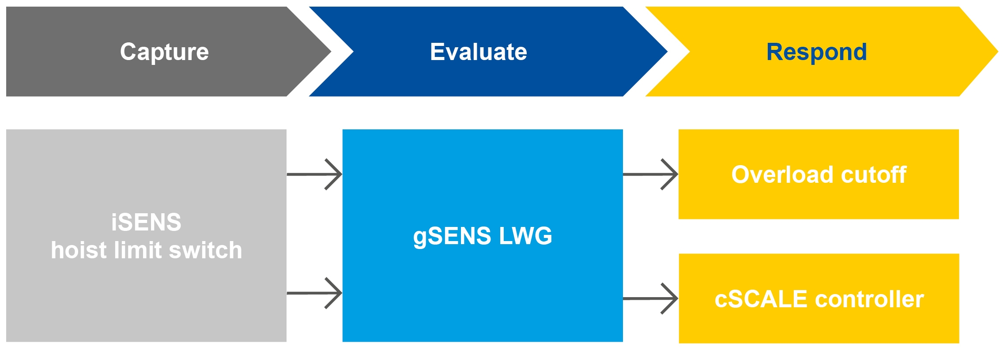
Figure 1: the safety chain of the gSENS LWG from WIKA Mobile Control

The right length/angle sensor for all time

100% backwards compatibility combined with 100% future safety: the new gSENS LWG generation unites proven methods for measuring length and angles with future-safe technology. Thanks to straightforward integration in new or existing applications, greater safety, reliability and performance can be achieved in mobile cranes today while also making them fit for the future.

For more information, please contact:

Yardena Hemmann
Marketing Manager
WIKA Mobile Control GmbH & Co. KG
Telephone: +49 (0)7243-3131
yardena.hemmann@wika.com
www.wika-mc.com/lwg

